This README provides an overview of the CS-340 Dashboard project develop for Grazioso Salvare, a search-and-rescue animal training organization. The main goal of this project was to design an interactive dashboard that lets Grazioso Salvare filter and find rescue dogs from a MongoDB database.
Project Functionality
The features of this application include:
Interactive Filtering: Radio buttons to select specific rescue types (Water Rescue, Mountain/Wilderness Rescue, Disaster/Individual Tracking) or reset the view.
Dynamic Data Table: A searchable table that displays animal records retrieved from the MongoDB database.
Data Visualization: A pie chart that dynamically updates to show the representation of preferred dog breeds based on the current filter.
Geospatial Mapping: A Leaflet map that displays the location of a selected animal from the data table.
Below are screenshots demonstrating the dashboard in various states of operation:
Water Rescue Filter
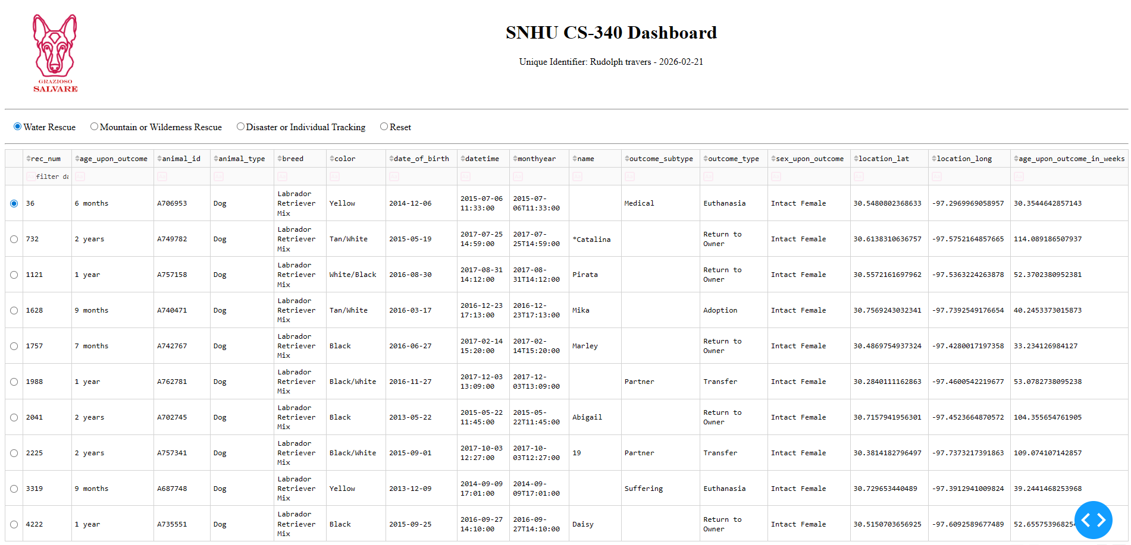
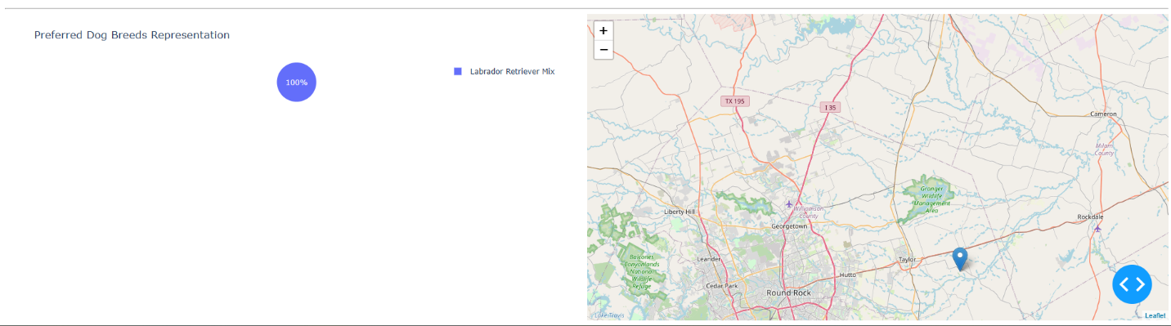
The "Water Rescue" filter targets specific breeds like Labrador Retriever Mixes within a specific age range.

Mountain or Wilderness Rescue Filter
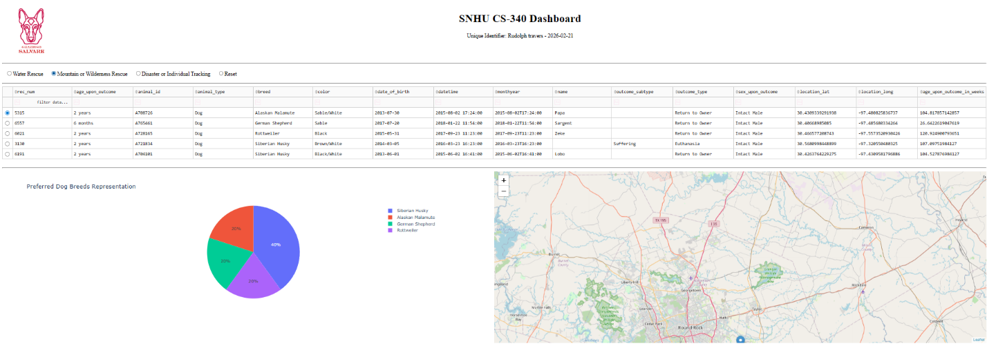
This filter isolates breeds such as German Shepherds, Malamutes, and Huskies.

Disaster or Individual Tracking Filter
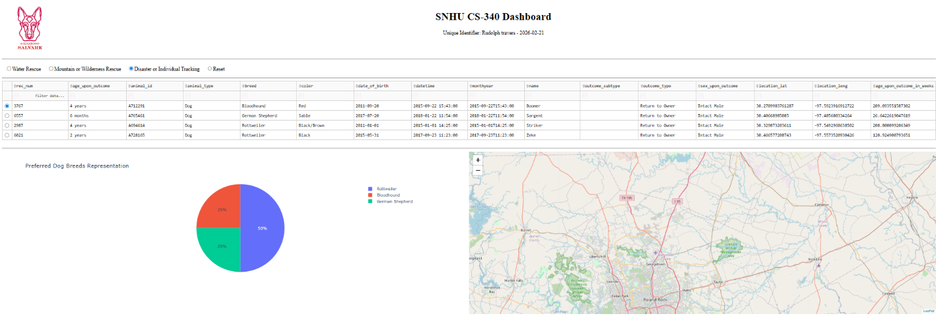
This view highlights breeds like Bloodhounds and Rottweilers suitable for tracking operations.
Dashboard Reset / Full View
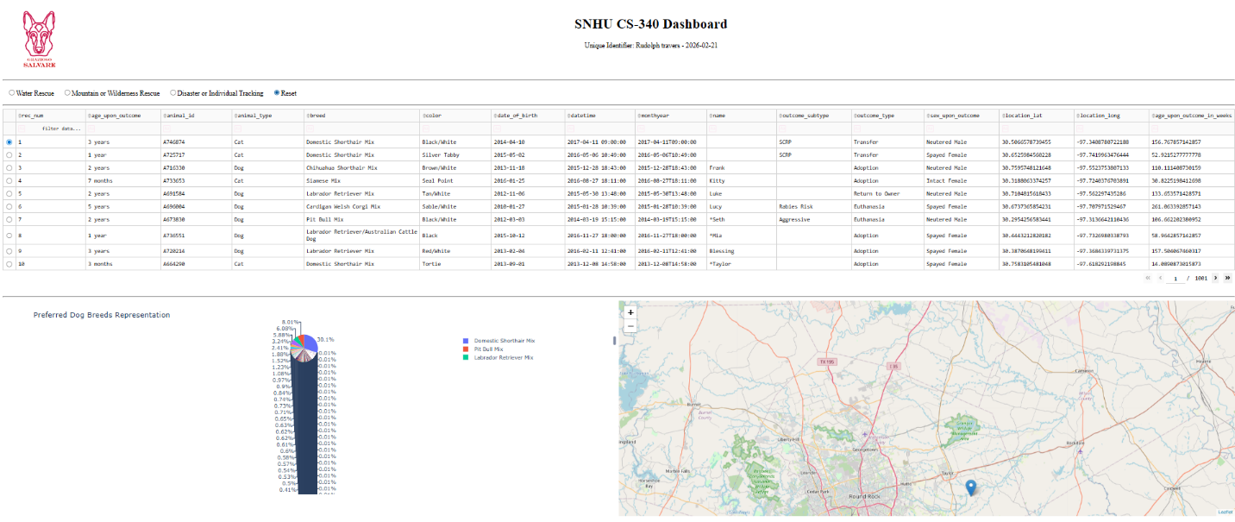
Displays the unfiltered state of the database.
Tools used for Development
Tool | Purpose | Rationale
MongoDB | Database | Ideal for managing animal shelter data; provides high scalability
Python | Programming Language | Chosen for its powerful data science libraries and easy integration with MongoDB via PyMongo.
Dash | Web Framework | Enables the creation of complex web applications within Python.
Jupyter Dash | Development Environment | Allows for quick prototyping and visual feedback within a Jupyter Notebook environment.
Leaflet | Geospatial Visualization | Used to design interactive maps to visualize animal locations.

When developing this dashboard MongoDB was used because it is a document-oriented database which was very useful. Its advantages were:
Schema Flexibility: Shelter data contains varying fields; MongoDB's BSON format allows for inconsistent data structures.
Python Interfacing: Through the animal_shelter CRUD module, MongoDB allows for direct mapping between Python dictionaries and database documents, making data retrieval highly efficient.
Dash was used provides the View and Controller structure:
The View: Defined in app.layout, using html to build the visual user interface.
The Controller: Handled by @app.callback functions. These listen for user inputs and links them with Python functions that update the data table, pie chart, and map.
Development Process
In order to complete this project the following steps were taken:
Data Import: Imported the Austin Animal Center (AAC) dataset into a MongoDB instance.
CRUD Module Development: Created AnimalShelter class in python to handle create, read, update, and delete operations.
Dashboard Layout: Designed the UI using Dash HTML components for a side-by-side graph and map view.
Challenges and Solutions
While designing this database I had challenges with the dash_table.DataTable crashing. To fix this I implemented a data cleaning step in the code to drop the _id column before sending the records to the table.
Resources
Dash Library: Plotly. (n.d.). Dash Python user guide. https://dash.plotly.com/
MongoDB: MongoDB, Inc. (n.d.). MongoDB documentation. https://www.mongodb.com/docs/
Dash Leaflet: Justesen, E. F. (n.d.). Dash leaflet documentation. https://dash-leaflet.herokuapp.com/

